The Whiteside Church Preservation Society would like to extend a very special thank-you to all those who made it possible to celebrate our July mass at St. Patrick’s Church in Whiteside. A sincere thanks to Celebrant Fr. Duncan MacIsaac, altar server Paul Tyrell, lectors Margaret Zinck and Mary McNamara, extraordinary minister Donelda Boudreau, ushers Francis White and Tom Chisholm, pianist Elizabeth McNamara, soloist Richard Cook, the St. Francis de Sales Choir, bell ringer Billy Proctor, and offertory collectors Paula Chisholm and Carmel Scanlan. Once again, we had the opportunity to come together in prayer and thanksgiving for our ancestors. The mass was offered for all those who are buried at St. Patrick’s Cemetery. After mass, Fr. Duncan offered a special blessing in the cemetery, and all those present were invited to share the name of an ancestor or family name that they wished to remember. The Whiteside Church Preservation Society unveiled a framed poem written by Mary Ellen Murphy McNamara in 1939 which is displayed in the church as part of our heritage collection. We thank all those who were able to attend, and we ask for your prayers and support as we continue to preserve St. Patrick’s Church in honour of your ancestors.
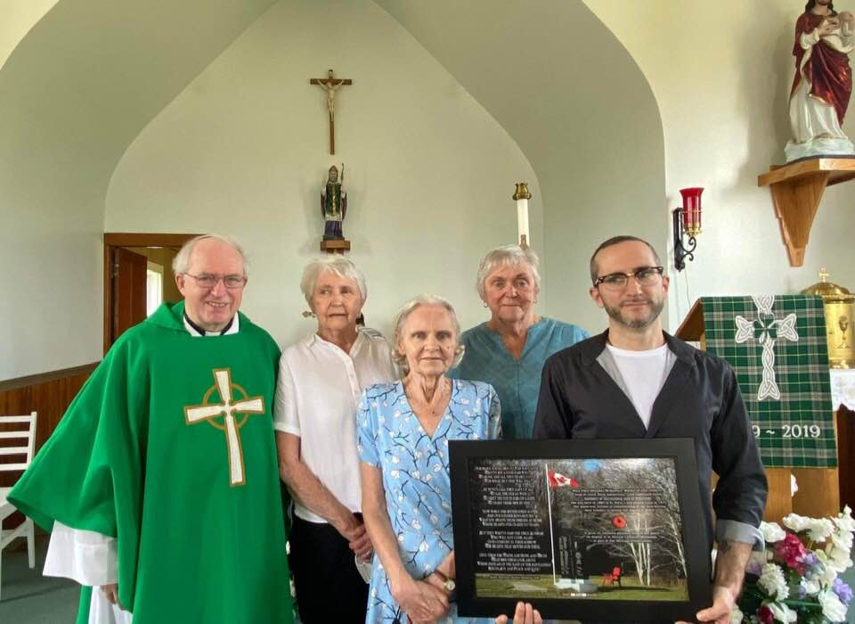
Poem beautifully read by great-grandson Adam McNamara. Father Duncan MacIsaac, Alice Jane, Paula, Eileen and Adam.

